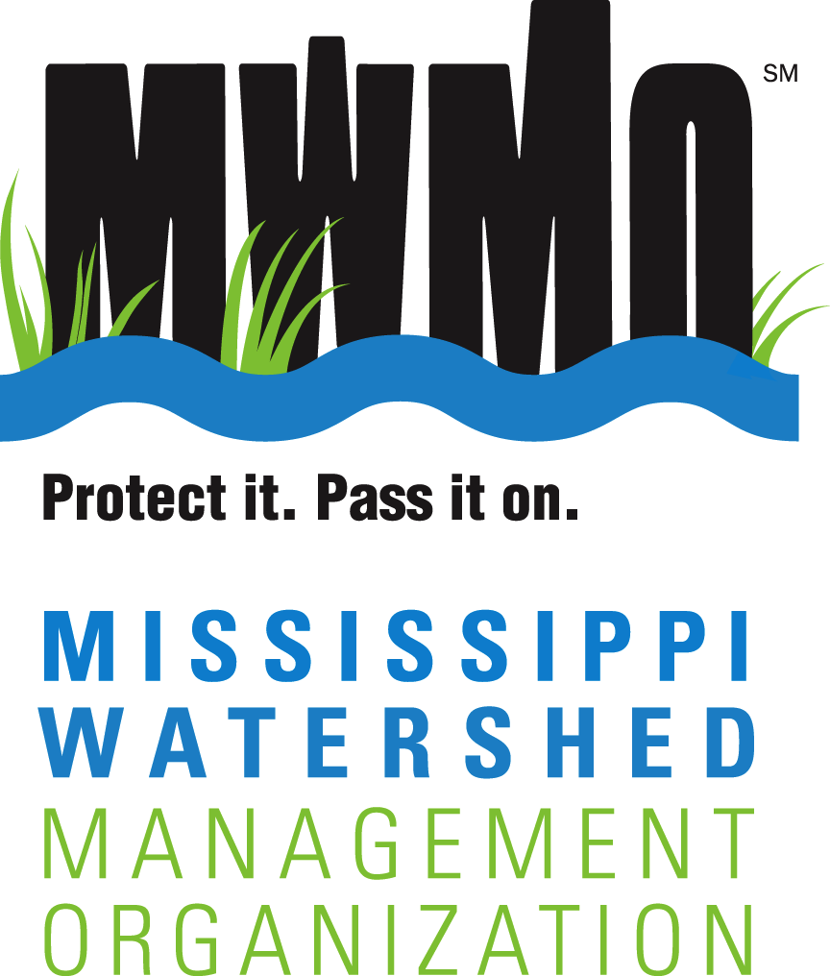
2522 Marshall Street NE 612-746-4970
Minneapolis, Minnesota 55418-3329 contacts@mwmo.org

mwmo.org
COMMUNITY ADVISORY COMMITTEE

MWMO Community Advisor Application

Personal Contact Information
Name: Click here to enter text.
Address: Click here to enter text.
Home Phone: Click here to enter text.
Cell Phone: Click here to enter text.
Work Phone: Click here to enter text.
Email: Click here to enter text.
Occupation: Click here to enter text.
Employer: Click here to enter text.
Preferred Method of Contact:
☐ Email ☐ Home Phone ☐ Cell Phone ☐ Work Phone
Availability for Meetings:
☐ Weekdays ☐ Weeknights ☐ Weekends

Please answer the questions on the following page.

Application Questions
Please answer the questions below as fully as you can. The text boxes will expand as you type.
1. Why would you like to serve on the Community Advisory Committee? (Please answer completely.)
Click here to enter text.
2. Describe your background, interests and expertise that would support your involvement with the CAC, such as experience in natural resources, education, government, planning, community engagement, etc. Include any applicable experience with civic, professional, community and volunteer organizations. (Please attach a resume. Resumes are not required, but assist staff in reviewing applications.)
Click here to enter text.
3. How did you hear about this opportunity?
☐ MWMO Website ☐ Neighborhood Group
☐ Email ☐ Current/Former CAC Member
☐ Newsletter ☐ Other: Click here to enter text.
4. Have you participated in other MWMO programs or projects?
☐ Stewardship Fund Program ☐ View from the Big River
☐ Capital Improvement Project ☐ Other: Click here to enter text.
5. Do you have interest in other opportunities at the MWMO? (helping with outreach events, contributing to newsletters, etc.)?
Please list:
Click here to enter text.

I certify that the above information is correct.
Signature: _________________________________________________ Date: ______________________________

Please return completed and signed application to:
Adam Flett
Outreach-Project Manager
Mississippi Watershed Management Organization
2522 Marshall Street NE
Minneapolis, MN 55418-3329
Include a Letter of Support with your application. These letters can come from your city, a neighborhood group or a civic organization in the area where you reside and with which you are involved. Applications are accepted year-round and open positions may be filled throughout the year. Applications to replace incumbents are due by Dec. 15. Applications are reviewed by the MWMO staff and the MWMO Executive Committee using the CAC Selection Criteria, and are approved by the MWMO Board of Commissioners. Appointment is for one year and is renewable annually. After appointment, all CAC members will be asked to sign the CAC Code of Conduct agreement. To review the Community Advisory Policy, Code of Conduct and Selection Criteria, visit: www.mwmo.org/about/community-advisory-committee.

Contact
Adam Flett
Outreach-Project Manager
aflett@mwmo.org
612-746-4988

