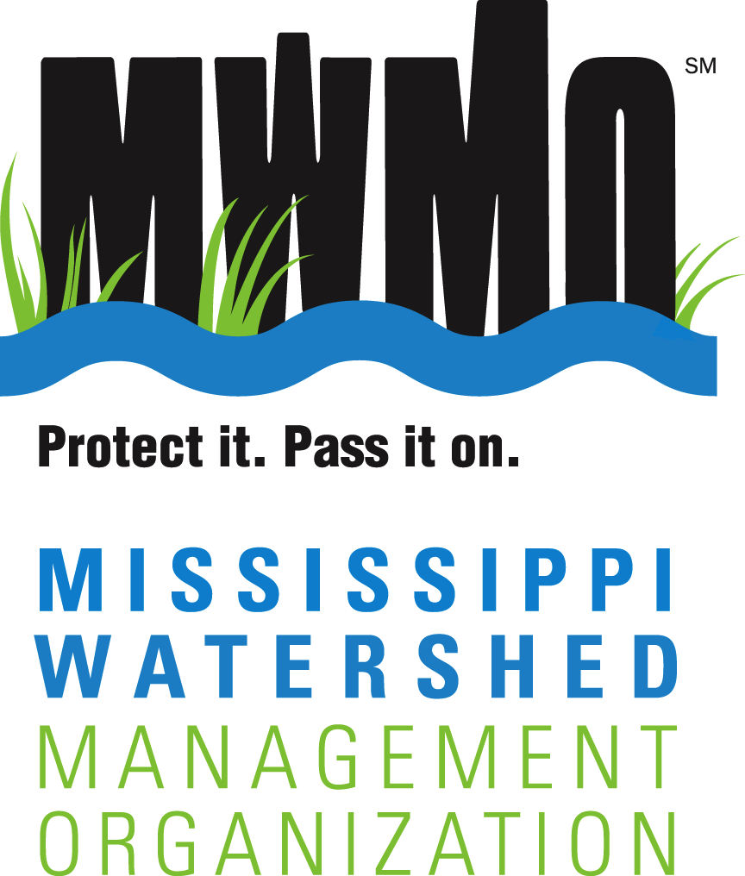
2522 Marshall Street NE 612-746-4970
Minneapolis, Minnesota 55418-3329 contacts@mwmo.org

mwmo.org
STEWARDSHIP FUND GRANTS

Mini Grant Application
Please call or email MWMO staff if you would like assistance in filling out this application or to discuss ideas and eligibility. Contact information is available at the end of this form.
As you answer the questions, include information that shows how your project meets these purposes of the Stewardship Fund program:
- Develops partnerships with community organizations
- Protects or improves the quality of water, habitat and natural resources
- Builds community understanding, knowledge and initiative related to water, habitat, and natural resource issues and solutions
Date: Click here to enter text.
Potential Project Name: Click here to enter text.

Federal Employer Identification Number (FEIN): Click here to enter text.
Is your project inside the MWMO boundaries? ☐ Yes ☐ No
Please use our “Find Your Watershed” feature to check.
Are you one of the following eligible applicants? ☐ Yes ☐ No
☐ Nonprofit organization | ☐ School
☐ Recognized neighborhood group | ☐ Local government agency
☐ Business or professional association | ☐ Other (please describe): Click here to enter text.

NOTE: Eligible applicants may not serve a dual role as project manager and project consultant.
See full Eligibility Requirements.

Complete the following questions:
Please answer the questions by typing where it says “Click here to enter text”.
- Describe the project in a short summary. Include ways in which you will educate others in learning how they can take actions to protect lakes, rivers, streams or wetlands. Include the steps you will take to engage others. Who is the audience you want to reach? Will you ask participants to take a specific action to protect water bodies? How will you know if you achieved your project goals? (500 words or less)

Click here to enter text.

- List up to three name(s) of partners or groups that are likely to collaborate with you in the project. List people or groups that will assist you in completing your project by providing funding, donating materials, offering labor, etc. Letters of support will be necessary later in the granting process if invited back for a final application.

Click here to enter text.
- Has the property owner given permission to build this project on their site? Permission letters are required from property owners where physical projects will be built before funding can be provided. Letters must include the property owner’s permission to build the project on their site as described by the applicant. Include the project address in the letter and indicate who will maintain the project for a minimum of 3-5 years after it’s installed. Signatures from all property owners are required on the letter.

☐ Yes ☐ No ☐ Need to find out ☐ We aren’t building a project

- What is the rough total cost of your project? This should be equal to or above your requested MWMO funding contribution. If you are invited to submit a final application, a complete budget form will be attached to that invitation email. You can attach a budget if you have already created one.
$ Click here to enter text.
- How much of the project’s cost do you want the MWMO to fund? (Up to $3,000.00)
Click here to enter text.
- What parts of the project do you want the MWMO to fund? Check if these costs are eligible for MWMO funding. Examples include staff time, native plants, soil, rocks, educational materials or a rental fee for a facility where you’ll hold an event.
Click here to enter text.

- What is a rough timeline for your project? (200 words or less)
See the example timeline below. Use whatever format you prefer. Just be sure to add details that show how you will plan, complete and reflect on your project at the end to learn lessons for the future.
April 2019–May 2019: Plan educational presentation and raingarden design
May 2019–June 2019: Give educational presentation; sign up volunteers for raingarden install
June–September, 2019: Install raingarden; create raingarden maintenance plan
September 2019–October 2019: Give tours of new raingarden site; encourage others to plant
October 2019–December 2019: Discuss project with partners to decide what went well and/or what might need to be changed in the future
October 2019–December 2019: Complete grant close out activities with MWMO, including a close out interview and sharing “lessons learned” with MWMO staff
Click here to enter text.

Thank you for taking the time to fill out this Mini Grant application. Contact MWMO staff or review the Mini Grant Guide to help you answer questions on the form. Send applications via email to:

Adam Flett
Communications and Outreach Specialist
(612) 746-4988, aflett@mwmo.org

